41.19: quantum numbers are either 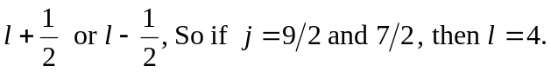
The letter used to describe 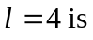 “g”

